Supplemental Tables and Figs.

Supplemental Table 1. Classification of Atrial Fibrillation (AF) in the ESC, AHA/ACC/HRS and CCS guidelines.
Classification of atrial fibrillation
ESC | AHA/ACC/HRS | CCS
Pattern:  - First-diagnosed AF  - Paroxysmal AF  - Persistent AF  - Long-standing persistent AF  - Permanent AF  Multifactorial (4S-AF):  - Stroke risk  - Symptom severity  - Sverity of AF-burden  - Substrate Severity | Pattern:  - Paroxysmal AF  - Persistent AF  - Long-standing persistent AF  - Permanent AF  Structural:  - Valvular vs. Nonvalvular AF | Pattern:  - Paroxysmal AF  - Persistent AF  - Long-standing persistent AF  - Permanent AF  Pathophysiology:  - Primary vs. secondary AF with subsequent reversible vs. provoked AF  Strucutural:  - Valvular vs. nonvalvular AF

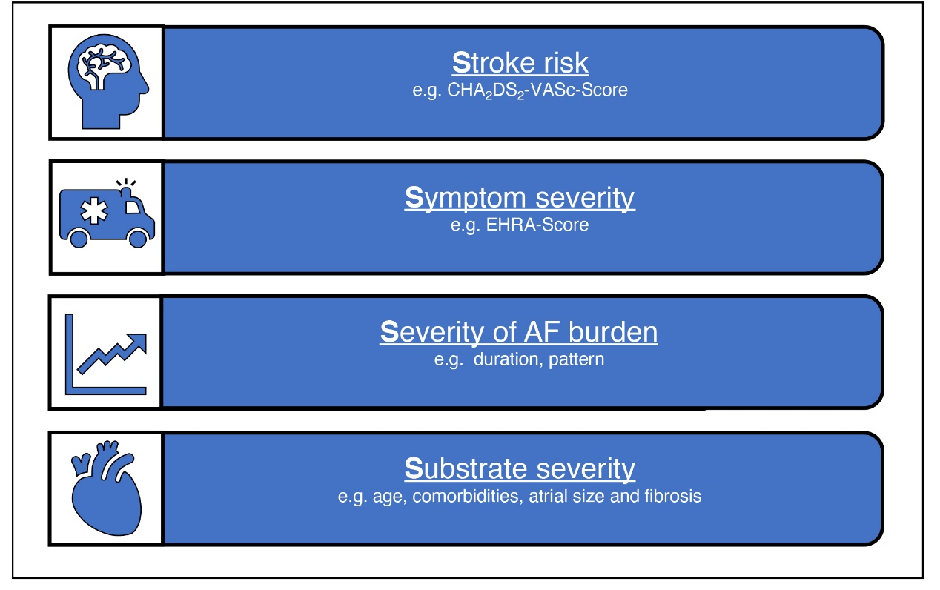
Supplementary Fig. 1. Newly introduced 4S-AF scheme to classify atrial fibrillation (AF) in the dimensions of stroke risk, symptom severity, severity of AF burden and substrate severity.

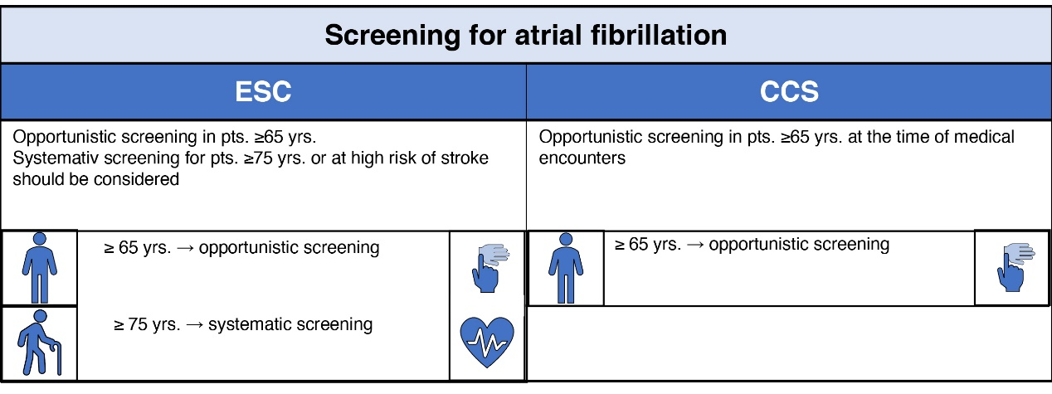
Supplementary Fig. 2. Recommendations on screening for atrial fibrillation from the ESC and CCS guidelines.

The ESC guidelines recommend opportunistic screening in patients (pts.) ≥65 years (yrs.) with ECG or pulse palpation and systematic screening for pts. ≥75 yrs. or at high risk of stroke.
The CCS guidelines recommend opportunistic screening for pts. ≥65 yrs. via pulse palpation.

Supplementary Table 3. EHRA and CCS SAF symptom scales as used in the ESC and CCS guidelines to classify the symptoms of atrial fibrillation (AF).
Symptom scales
ESC  EHRA symptom scale |  | CCS  CCS-Severity of atrial fibirillation scale
Class | Definition | Class | Definition
1 | AF does not cause any symptoms | 0 | Asymptomatic with respect to AF
2a | Normal daily acitvity not affected by symptoms related to AF | 1 | Symptoms attributable to AF have minimal effect on patient´s general quality of life
2b | Normal daily acitvity not affected by symptoms related to AF, but patient troubled by symptoms | 2 | Symptoms attributable to AF have minor effect on patient´s general quality of life
3 | Normal daily acitvity affected by symptoms related to AF | 3 | Symptoms attributable to AF have moderate effect on patient´s general quality of life
4 | Normal daily acitvity discontinued | 4 | Symptoms attributable to AF have severe effect on patient´s general quality of life

Supplementary Table 4. ESC, AHA/ACC/HRS and CCS guidelines on the criteria for dose reduction of DOACs.
Dose reduction cirteria for DOACs
ESC | AHA/ACC/HRS | CCS
Rivaroxaban
CrCl: 15-49ml/min | CrCl: 15-50ml/min | CrCl: 30-49ml/min  CrCl: <30ml/min: no data
Apixaban
At least 2 of 3 criteria:
- Age ≥80 yrs.
- Body weight ≤ 60kg
- Serum creatinine ≥1.5 mg/dl
Edoxaban
- CrCl: 15-50ml/min  - Body weight ≤60 kg  - Combination with potent p-GP-inhibitors | - CrCl: 15-50ml/min | - CrCl: 15-50ml/min  - Body weight ≤60 kg  - Combination with potent p-GP-inhibitors
Dabigatran
- Age ≥80 yrs.  - Combination with Verapamil  - Increased bleeding risk | - CrCl: 15-30ml/min (75mg b.d.) | - CrCl: 30-49ml/min  - Age ≥80 yrs.  - Age ≥75 yrs. + bleeding risk factors
b.d., bis in die (twice a day); CrCl, creatinine clearance.

Supplementary Table 5. ESC, AHA/ACC/HRS and CCS guidelines on left atrial appendage occlusion to prevent stroke.
Left atrial appendage occlusion
ESC | AHA/ACC/HRS | CCS
Indication
Left atrial appendage occlusion (LAAO):
- Might be considered for stroke prevention in AF pts. with contraindications for long-term anticoagulation treatment (IIb in ESC and AHA guidelines)
Surgical occlusion or exclusion
- May be considered in AF pats. undergoing cardiac surgery (IIb) |  | - May be considered in AF pats. undergoing cardiac surgery with contraindications for long-term anticoagulation treatment
AF, atrial fibrillation; LAAO, left atrial appendage occlusion.

Supplementary Table 6. ESC, AHA/ACC/HRS and CCS guidelines on anticoagulation in certain situations.
Anticoagulation in certain situations
ESC | AHA/ACC/HRS | CCS
Anticoagulation and cardioversion
- Anticoagulation for ≥3 weeks before cardioversion is recommended
- Alternatively cardioversion can be performed after thrombus-exclusion with TOE without previous OAC  - Cardioversion can be performed without TOE in AF <48h  - In patients with >24h AF, OAC for minimum 4 weeks is recommended, independend of rhythm post-cardioversion and stroke-risk  - In AF <24 h and a very low stroke risk (CHA₂DS₂-VASc of 0 in men or 1 in women) post-cardioversion anti-coagulation for 4 weeks may be omitted | - Alternatively cardioversion can be performed after thrombus-exclusion with TOE, when OAC is established before TOE  - In patients with >48h AF, OAC for minimum 4 weeks is recommended, independend of stroke-risk  - For patients with AF <48h and a very low stroke risk (CHA₂DS₂-VASc of 0 in men or 1 in women) OAC may be considered before cardioversion, without the need for postcardioversion oral anticoagulation. | - Alternatively cardioversion can be performed after thrombus-exclusion with TOE without previous OAC  - Cardioversion without 3 weeks of OAC or TOE is possible in:  - non-valvular AF onset within 12h  - non-valvular AF onset between 12-48h and CHADS₂ score of 0 or 1  - OAC for 4 weeks before cardioversion independent of stroke risk and AF-duration
Anticoagulation and catheter ablation
- OAC should be continued for 2 months post-ablation independent of stroke risk.
- Previous OAC for minimum 3 weeks or TOE is recommendet to exclude LA-thrombus in patients with stroke risk factors  - OAC with warfarin, dabigatran, rivaroxaban, apixaban, or edoxaban should not be interrupted for ablation.  - Long-term anticoagulation is based on CHA₂DS₂-VASc-Score and not on success of the ablation | - AF catheter ablation should not be performed in patients who cannot be treated with anticoagulant therapy during and after the procedure. | - OAC should not be interrupted for ablation.  - Long-term anticoagulation is based on CHADS-65-Score and not on success of the ablation
AF, atrial fibrillation; OAC, oral anticoagulation; TOE, Transoesophageal echocardiography.

Supplementary Table 7. Anticoagulation following Percutaneous coronary intervention (PCI) in acute coronary syndrome (ACS) and chronic coronary syndrome (CCS).
Anticoagulation and PCI in ACS and CCS
ESC | AHA/ACC/HRS | CCS
Anticoagulation and antiplatelet therapy
In combination with antiplatelet therapy:  - NOACs are preferred over VKA in pts. eligibile  - In pts. at high bleeding risk (HAS-BLED ≥3) reduced dose of rivaroxaban (15mg o.d.) or dabigatran (110mg b.i.d.) should be considered  - In patients on VKA an INR of 2.0 - 2.5 and TTR>70% should be striven | In combination with antiplatelet therapy:  - low-dose rivaroxaban (15mg o.d.) is reasonable to reduce bleeding risk  - VKA are reasonable  - dabigatran (150mg b.i.d) is reasonable | In combination with antiplatelet therapy:  - NOACs are prefered over VKA in pts. eligibilie  - rivaroxaban should be given 15mg o.d. without dose-reduction criteria (10mg o.d. in patients with creatinin clearance 30-50ml/min)  - clopidogrel is the prefered P2Y12 inhibitor  - In patients on VKA the lower INR target range should be striven
Anticoagulation following PCI for ACS
- In patients with uncomplicated PCI for ACS, triple therapy with aspirin should be limited ≤1 week to reduce bleeding risk and dual therapy with OAC and a P2Y12 inhibitor (preferably clopidogrel) for up to 12 months is recommended.  - Triple therapy with aspirin, clopidogrel, and an OAC for longer than 1 week after an ACS should be considered when the risk of stent thrombosis outweighs the bleeding risk, with a total duration ≤1 month | - Double-therapy with an OAC plus a P2Y12 inhibitor without aspirin can be considered  - Triple therapy with aspirin, clopidogrel, and an OAC can be limited to 4-6 weeks. | - Pts. with high stroke risk (≥65 yrs. or CHADS₂: ≥1) and PCI for ACS should initially receive triple therapy (OAC + P2Y12 inhibitor + aspirin) for 1d to 1 month.  - OAC and P2Y12 inhibitor should be given for up to 12 month.
Anticoagulation following PCI for CCS
- In patients with uncomplicated PCI for CCS, triple therapy with aspirin should be limited ≤1 week to reduce bleeding risk and dual therapy with OAC and a P2Y12 inhibitor (preferably clopidogrel) for up to 6 months is recommended.  - Triple therapy with aspirin, clopidogrel, and an OAC for longer than 1 week after an ACS should be considered when the risk of stent thrombosis outweighs the bleeding risk, with a total duration ≤1 month | - No recommendations on elective PCI | - Pat. with high stroke risk (≥65 yrs. or CHADS₂: ≥1) and uncomplicated elective PCI should receive dual therapy (OAC + P2Y12 inhibitor) for 1-12 month after elective PCI  - Pat. with high stroke risk (≥65 yrs. or CHADS₂: ≥1) and high-risk PCI should initially receive triple therapy (OAC + P2Y12 inhibitor + aspirin). Aspirin can be discontinued the day after PCI. OAC with P2Y12 inhibitor should be given for up to 12 month.
ACS, acute coronary syndrome; AF, atrial fibrillation; CCS, chronic coronary syndrome; NOAC, Non-vitamin K antagonist oral anticoagulant; VKA, Vitamin K antagonist; PCI, Percutaneous coronary intervention; yrs., years; INR, International normalized ratio; o.d., omni die (once daily); b.d., bis in die (twice a day).

Supplementary Table 8. ESC, AHA/ACC/HRS and CCS guidelines on antiarrhythmic drug therapy.
Antiarrhythmic drug therapy
ESC | AHA/ACC/HRS | CCS
Pharmaceutical cardioversion
Possible drugs:
- Amiodarone (limited and delayed effect, significant side effects)
Further drugs:  - Flecainide and propafenone (prompt and safe + betablocker)  - Vernakalant (most effective)  - Ibutilide | Further drugs:  - Ibutilide (effective in atrial flutter but significant proarrhythmia)  - Flecainide and propafenone (prompt and safe + betablocker) | Further drugs:  - Procainamide (most frequently used)  - Ibutilide (effective in atrial flutter but significant proarrhythmia)  - Vernakalant (not significantly more effective)  - Flecainide and Propafenone (not available for i.v. use in Canada)
Longterm antiarrhythmic drug therapy
- Safety rather than efficacy should guide AAD decision
Flecainide/Propafenone
- Should not be used in ischemic heart disease and/or significant structural heart disease
- Combination with betablockers recommended
Flecainide/Propafenone
- Ischemia risk assesment in pts. >50yrs. or severe risk factors
- Annual reassessment of symptoms of coronary artery disease
Amiodarone
- Most effective
- Multiple side effects
- Multiple contraindications
Dronedarone  - Less-effective but less side efects compared to amiodarone  - Reduced CV-death and hospitalisations in pts. with CV-comorbidities  - Increased mortality in pts. with decompensated heart failure, permanent AF  - Might be 1st choice due to amount of safety data  - Contrainidications: heart failure, permanent AF, NYHA III/IV  Sotalol  - Significant risk of TdP  - Heterogenous data on overall-survival | Dronedarone  - Less-effective but less side efects compared to amiodarone  - Reduced mortality in paroxysmal and persistent AF and AFL with risk of thrombembolism  - Increased mortality in pts. with heart failure, HFrEF and permanent AF  Sotalol  - Less effective than amiodarone  - Raised mortality  - No clear recommendation whether to start in inpatient settings | Dronedarone  - Reduced mortality in paroxysmal and persistent AF and AFL with at least 1 additional risk factor for death  - To be avoided in pts. with permanent AF, LVEF ≤40%, HF, high-degree AV conduction disorders, etc.  - Liver function tests every 3 months for the first year, every 6 months from the second year on  Sotalol  - Severe risk of QT prolongation and TdP  - Multiple contraindications
Disopyramid  - Significantly increased mortality  - Possible in vagal AF  - Reduces LV outflow obstruction and symptoms in HOCM |  | - Disopyramid not discussed
AAD, antiarrhythmic drug; AF, atrial fibrillation; AFL, Atrial Flutter; CV, cardiovascular; HFrEF, Heart failure with reduced ejection fraction; HOCM, Hypertrophic obstructive cardiomyopathy; i.v., intravenous; LV, left ventricle; NYHA, New York Heart Association; pts., patients; TdP, Torsade de pointes tachycardia; yrs., years.

